INTERACTIVE CHAT BOT ROUND 2

Navya Sri Kamireddy

R11891529

Wireshark captures and analyzes network traffic, displaying information such as packet headers, protocols, source and destination addresses, and sequence numbers. This facilitates tracking the flow of data between the chatbot's user interface and backend.

Below is a detailed explanation for data tracing using wireshark for the 5 prompts given by the user.

**PROMPT 1:**

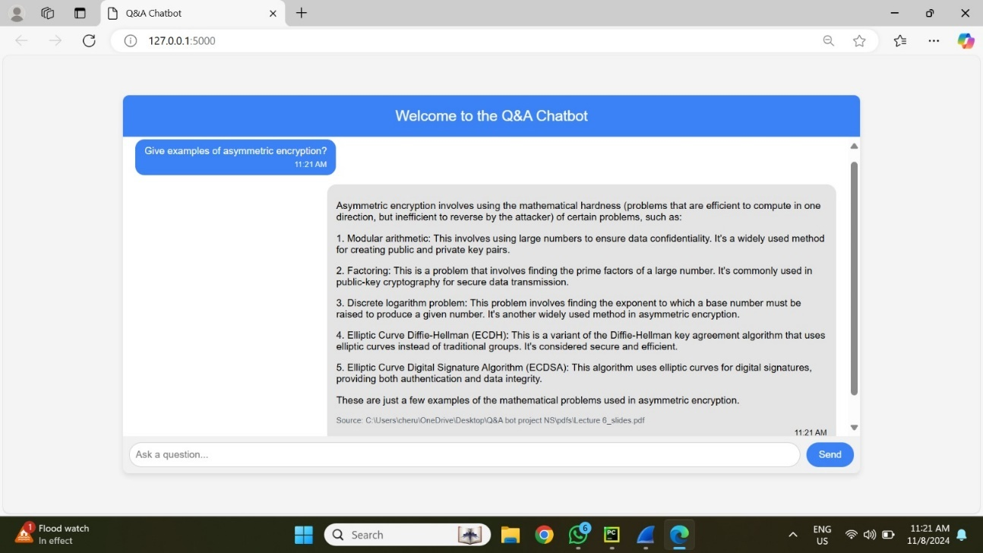

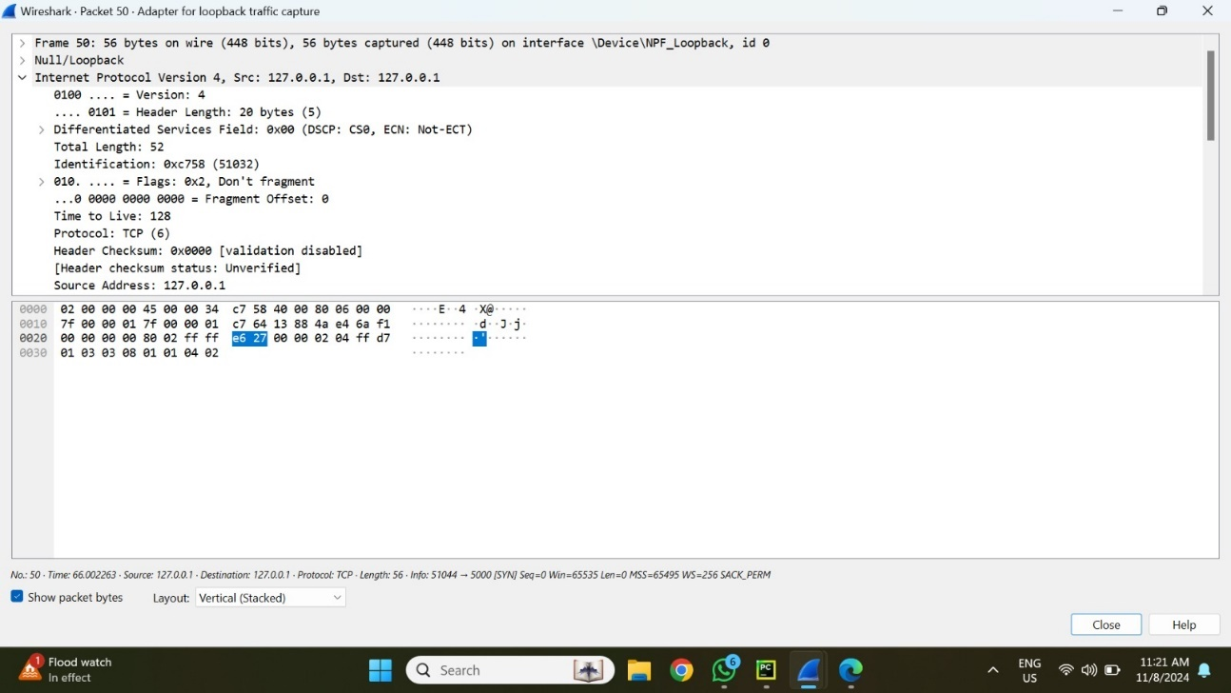

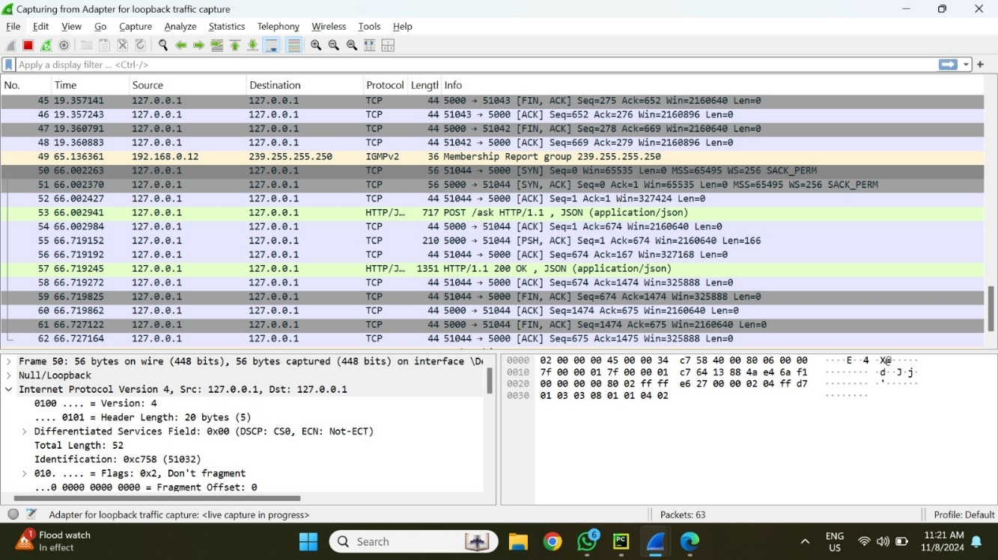

**Packet Analysis for User Query and Bot response**

**Key elements:**

Local Communication:

* Source port: 51044.
* Destination Port: 5000.

TCP protocol is dependable and connection-oriented.

TCP Three-Way Handshake:

* SYN: An initial packet from source (51044) to destination (5000) to initiate communication.
* SYN-ACK: Destination responds, verifying the connection.
* ACK: Final acknowledgement, which establishes a reliable channel.

Data Transmission:

* The chatbot's inquiry ("Give examples of asymmetric encryption") is sent over HTTP POST.
* The server responds with a JSON-encoded answer, as shown in the HTTP 200 OK response packet.

Connection Closed:

* FIN packets indicate the conclusion of the session following data exchange.

**Snapshot Summary**

Snapshot 1: Shows the prompt entered into the chatbot.

Snapshot 2: Packet details, including source, destination, and TCP header information.

Snapshot 3: List of collected packets, including HTTP requests and responses.

Wireshark allows you to monitor data flow, check for delays or faults, and ensure that the prompt-response process is running properly. This is useful for troubleshooting and maintaining data integrity in networked applications.

**PROMPT 2:**

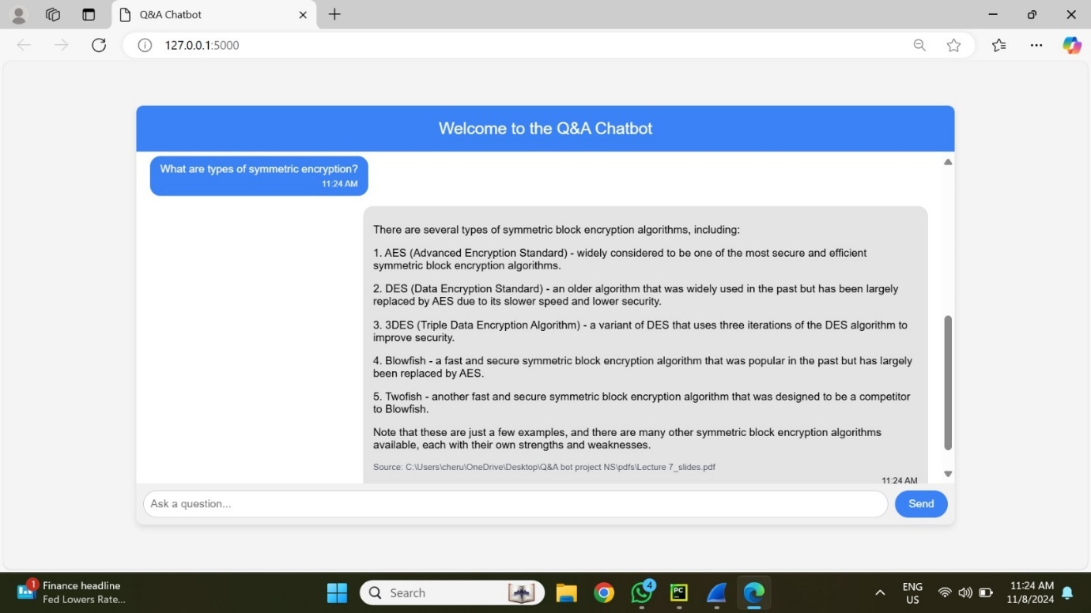

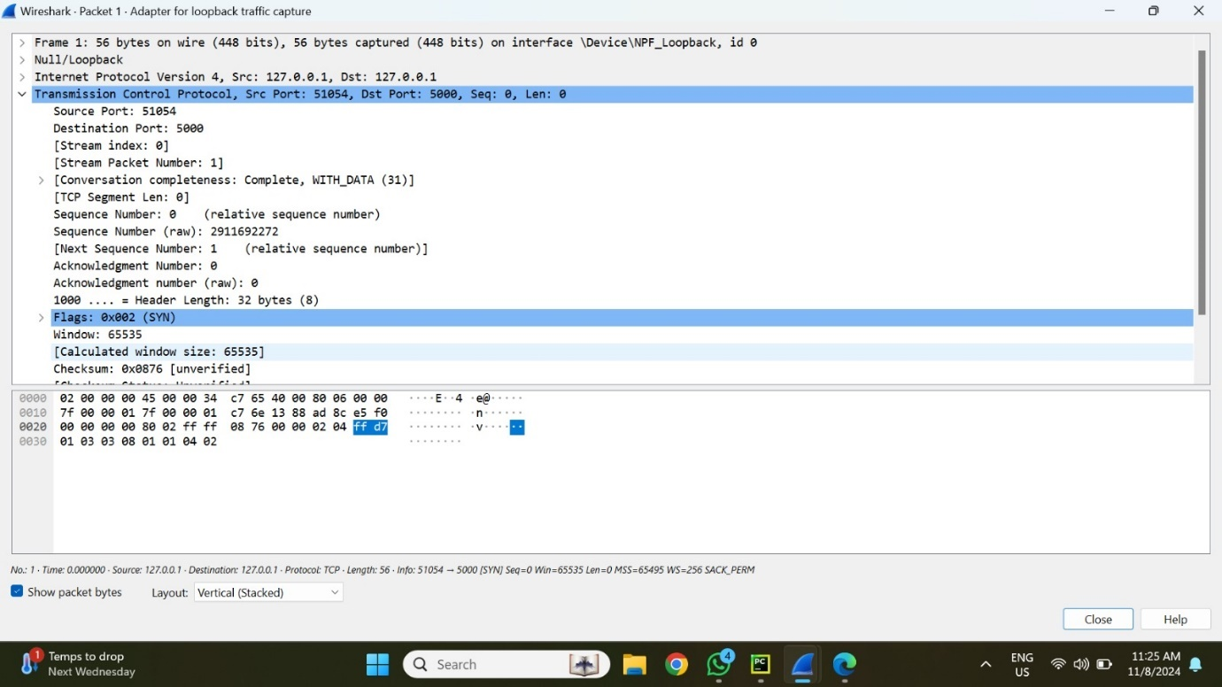

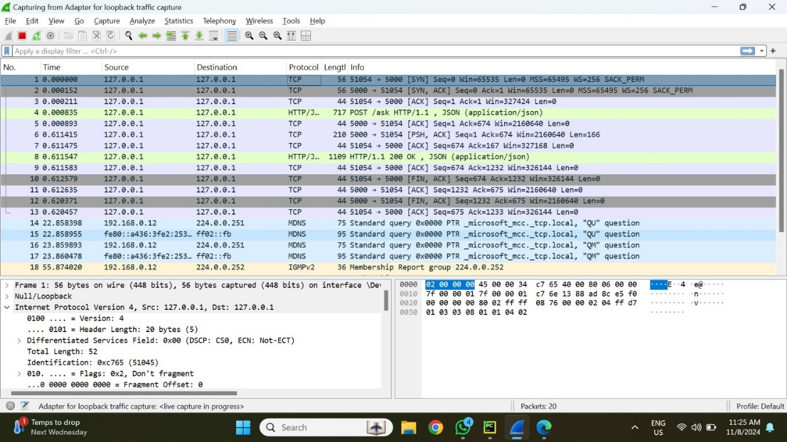

**Packet Analysis for User Query and Bot response**

**Key elements:**

Local Communication:

* Source port: 51054.
* Destination Port: 5000.

TCP protocol is dependable and connection-oriented.

TCP Three-Way Handshake:

* SYN: An initial packet from source (51054) to destination (5000) to initiate communication.
* SYN-ACK: Destination responds, verifying the connection.
* ACK: Final acknowledgement, which establishes a reliable channel.

Data Transmission:

* The chatbot's inquiry ("Give examples of asymmetric encryption") is sent over HTTP POST.
* The server responds with a JSON-encoded answer, as shown in the HTTP 200 OK response packet.

Connection Closed:

* FIN packets indicate the conclusion of the session following data exchange.

**Snapshot Summary**

Snapshot 1: Shows the prompt entered into the chatbot.

Snapshot 2: Packet details, including source, destination, and TCP header information.

Snapshot 3: List of collected packets, including HTTP requests and responses.

Wireshark allows you to monitor data flow, check for delays or faults, and ensure that the prompt-response process is running properly. This is useful for troubleshooting and maintaining data integrity in networked applications.

**PROMPT 3:**

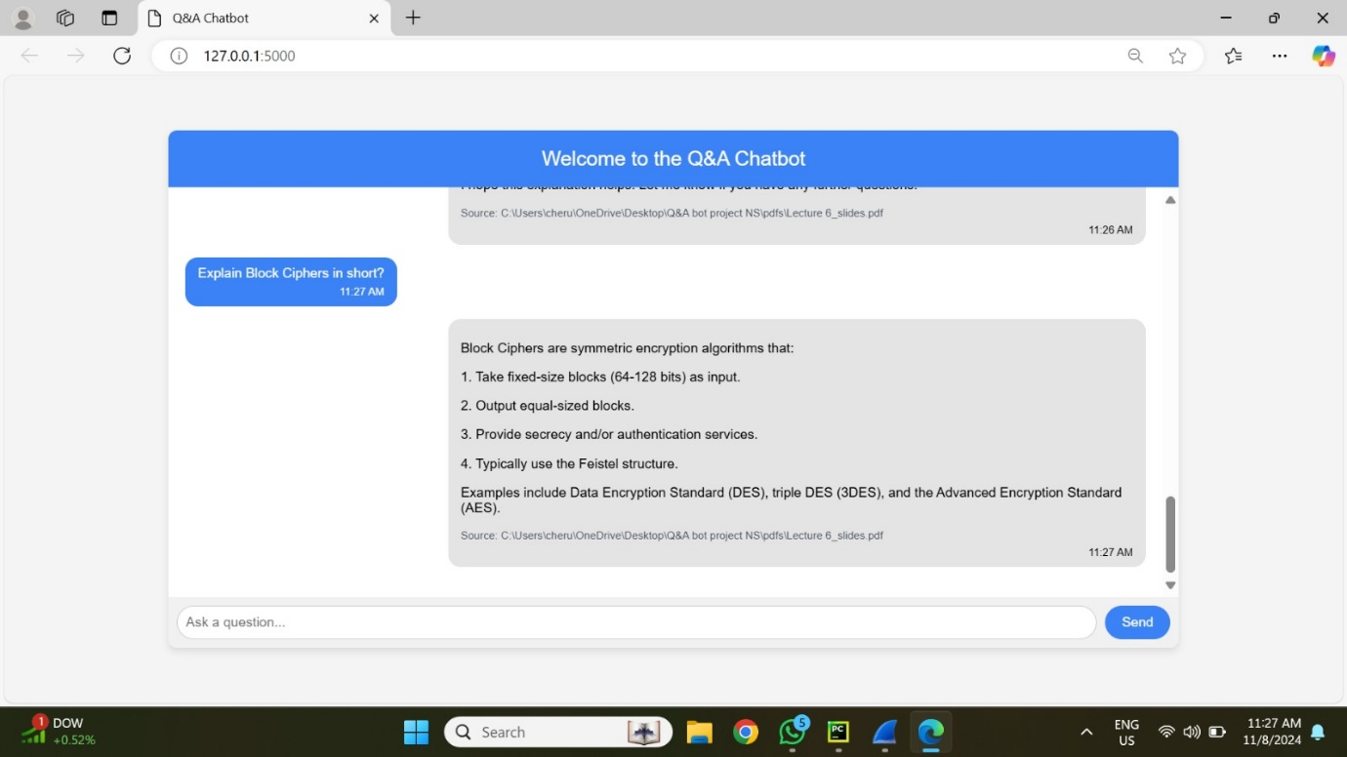

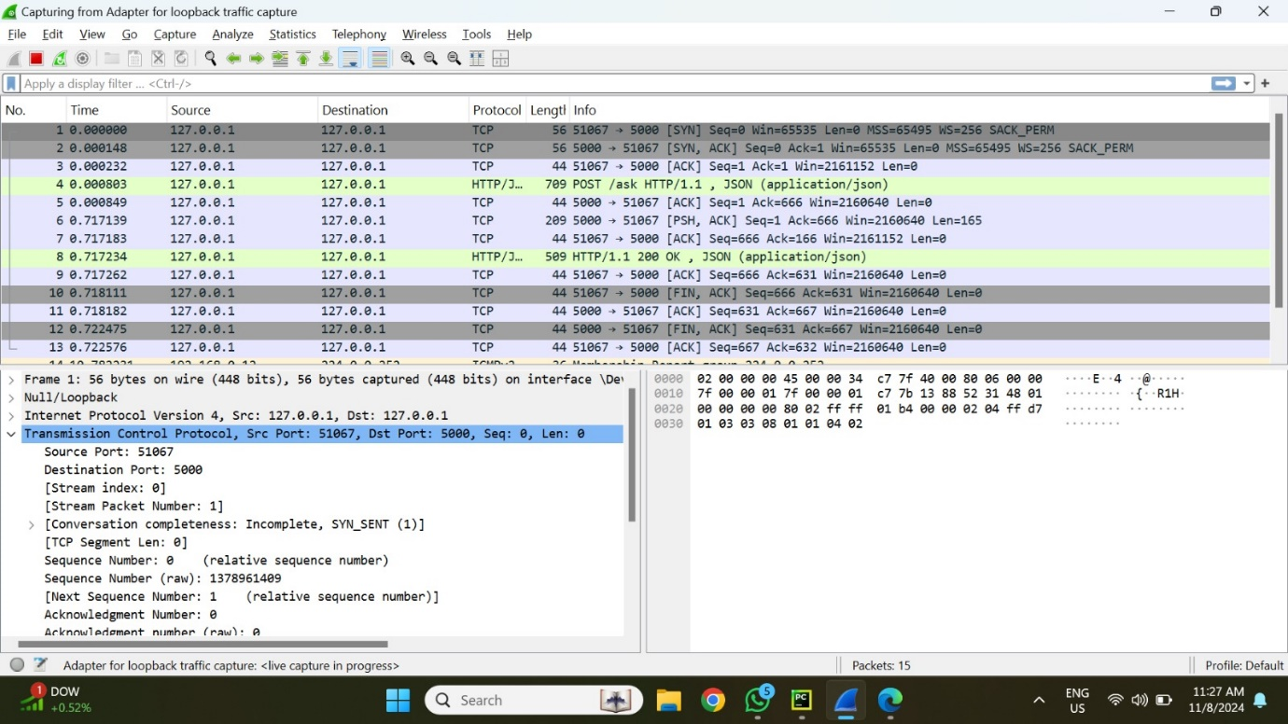

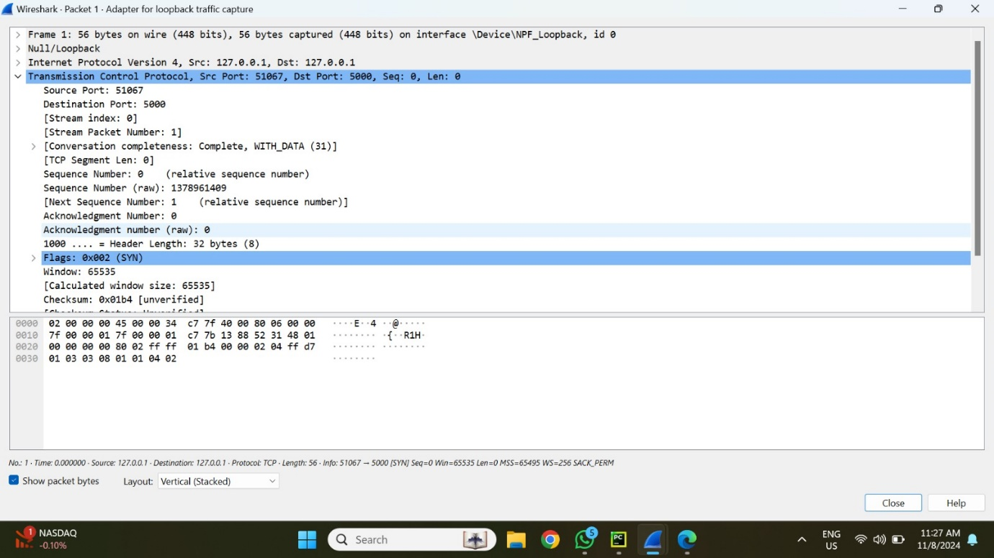

**Packet Analysis for User Query and Bot response**

**Key elements:**

Local Communication:

* Source port: 51067.
* Destination Port: 5000.

TCP protocol is dependable and connection-oriented.

TCP Three-Way Handshake:

* SYN: An initial packet from source (51067) to destination (5000) to initiate communication.
* SYN-ACK: Destination responds, verifying the connection.
* ACK: Final acknowledgement, which establishes a reliable channel.

Data Transmission:

* The chatbot's inquiry ("Give examples of asymmetric encryption") is sent over HTTP POST.
* The server responds with a JSON-encoded answer, as shown in the HTTP 200 OK response packet.

Connection Closed:

* FIN packets indicate the conclusion of the session following data exchange.

**Snapshot Summary**

Snapshot 1: Shows the prompt entered into the chatbot.

Snapshot 2: Packet details, including source, destination, and TCP header information.

Snapshot 3: List of collected packets, including HTTP requests and responses.

Wireshark allows you to monitor data flow, check for delays or faults, and ensure that the prompt-response process is running properly. This is useful for troubleshooting and maintaining data integrity in networked applications.

**PROMPT 4:**

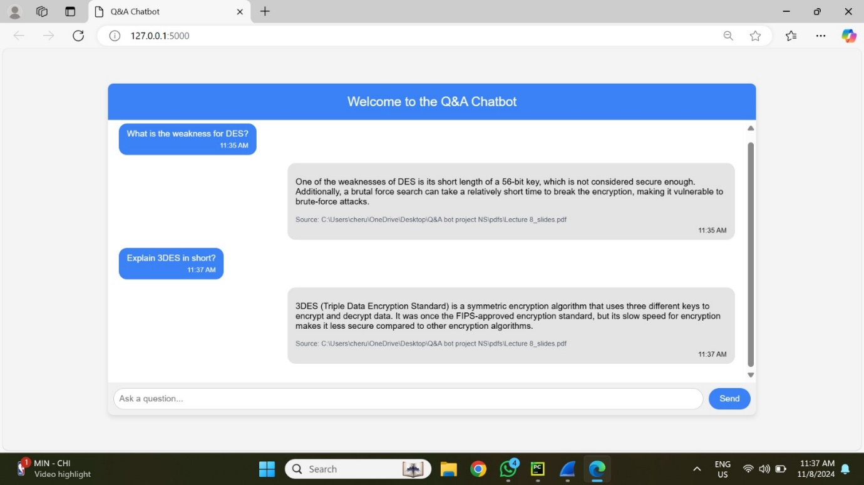

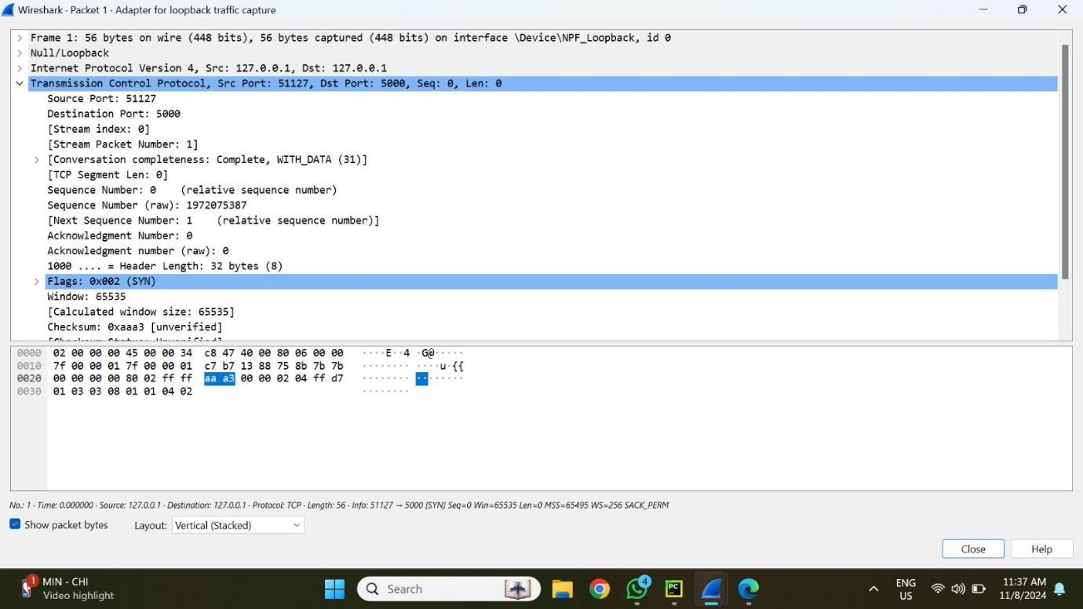

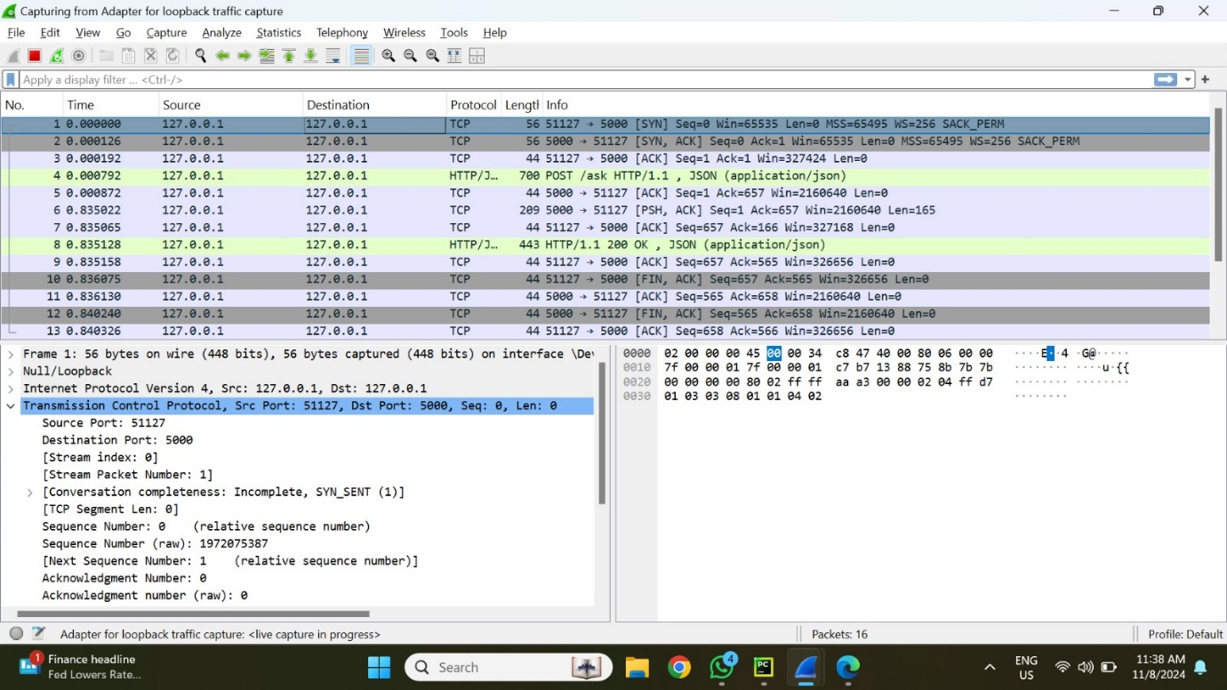

**Packet Analysis for User Query and Bot response**

**Key elements:**

Local Communication:

* Source port: 51127.
* Destination Port: 5000.

TCP protocol is dependable and connection-oriented.

TCP Three-Way Handshake:

* SYN: An initial packet from source (51127) to destination (5000) to initiate communication.
* SYN-ACK: Destination responds, verifying the connection.
* ACK: Final acknowledgement, which establishes a reliable channel.

Data Transmission:

* The chatbot's inquiry ("Give examples of asymmetric encryption") is sent over HTTP POST.
* The server responds with a JSON-encoded answer, as shown in the HTTP 200 OK response packet.

Connection Closed:

* FIN packets indicate the conclusion of the session following data exchange.

**Snapshot Summary**

Snapshot 1: Shows the prompt entered into the chatbot.

Snapshot 2: Packet details, including source, destination, and TCP header information.

Snapshot 3: List of collected packets, including HTTP requests and responses.

Wireshark allows you to monitor data flow, check for delays or faults, and ensure that the prompt-response process is running properly. This is useful for troubleshooting and maintaining data integrity in networked applications.

**PROMPT 5:**

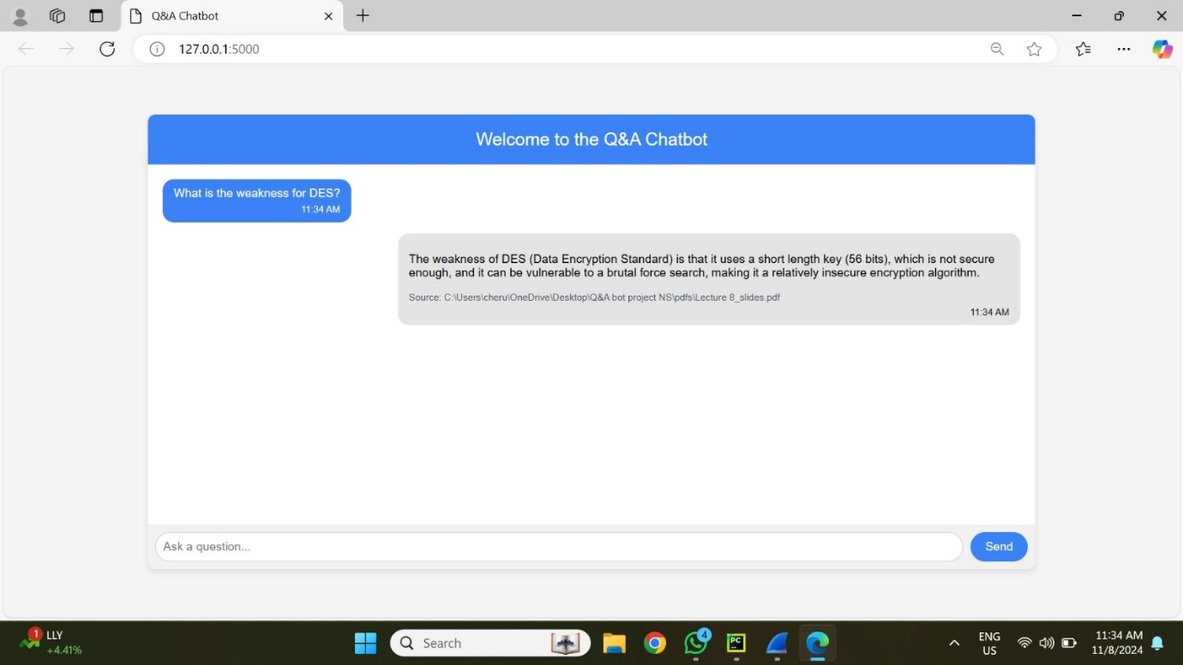

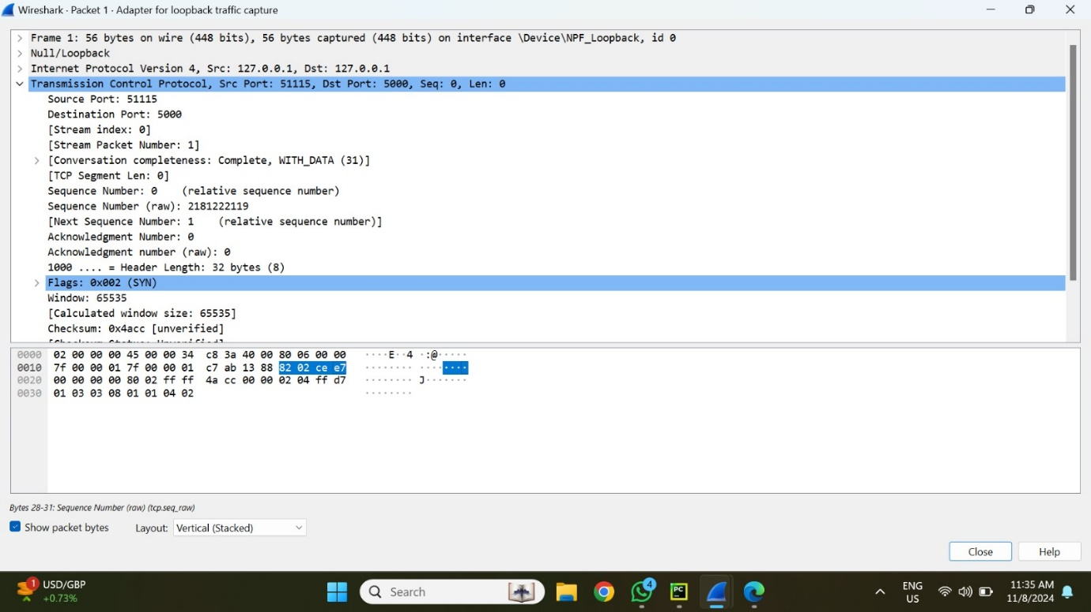

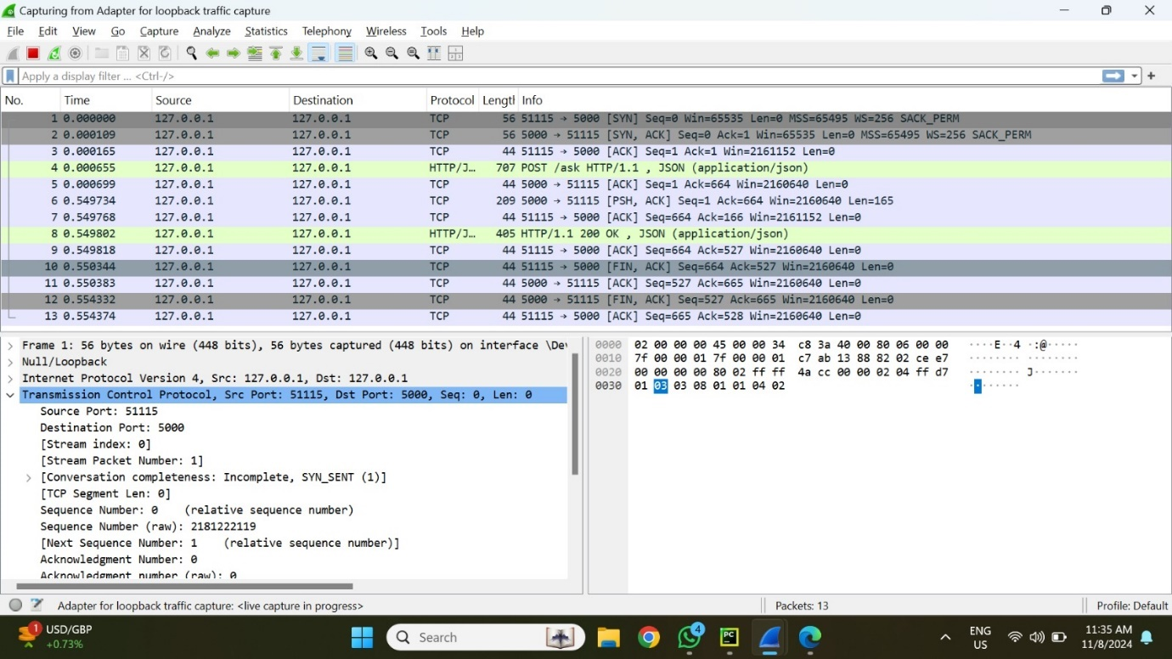

**Packet Analysis for User Query and Bot response**

**Key elements:**

Local Communication:

* Source port: 51115.
* Destination Port: 5000.

TCP protocol is dependable and connection-oriented.

TCP Three-Way Handshake:

* SYN: An initial packet from source (51115) to destination (5000) to initiate communication.
* SYN-ACK: Destination responds, verifying the connection.
* ACK: Final acknowledgement, which establishes a reliable channel.

Data Transmission:

* The chatbot's inquiry ("Give examples of asymmetric encryption") is sent over HTTP POST.
* The server responds with a JSON-encoded answer, as shown in the HTTP 200 OK response packet.

Connection Closed:

* FIN packets indicate the conclusion of the session following data exchange.

**Snapshot Summary**

Snapshot 1: Shows the prompt entered into the chatbot.

Snapshot 2: Packet details, including source, destination, and TCP header information.

Snapshot 3: List of collected packets, including HTTP requests and responses.

Wireshark allows you to monitor data flow, check for delays or faults, and ensure that the prompt-response process is running properly. This is useful for troubleshooting and maintaining data integrity in networked applications.